Kammavari Sangham (R) 1952, K.S.Group of Institutions

K S INSTITUTE OF TECHNOLOGY
#14, Raghuvanahalli, Kanakapura Main Road,Bengaluru-560109


DEPARTMENT OF
ARTIFICIAL INTELLIGENCE & MACHINE LEARNING

III SEMESTER

LAB MANUAL FOR

OPERATING SYSTEM LAB
[BCS303]
By

Prof. Divya C P
Assistant Professor
Department of AIML

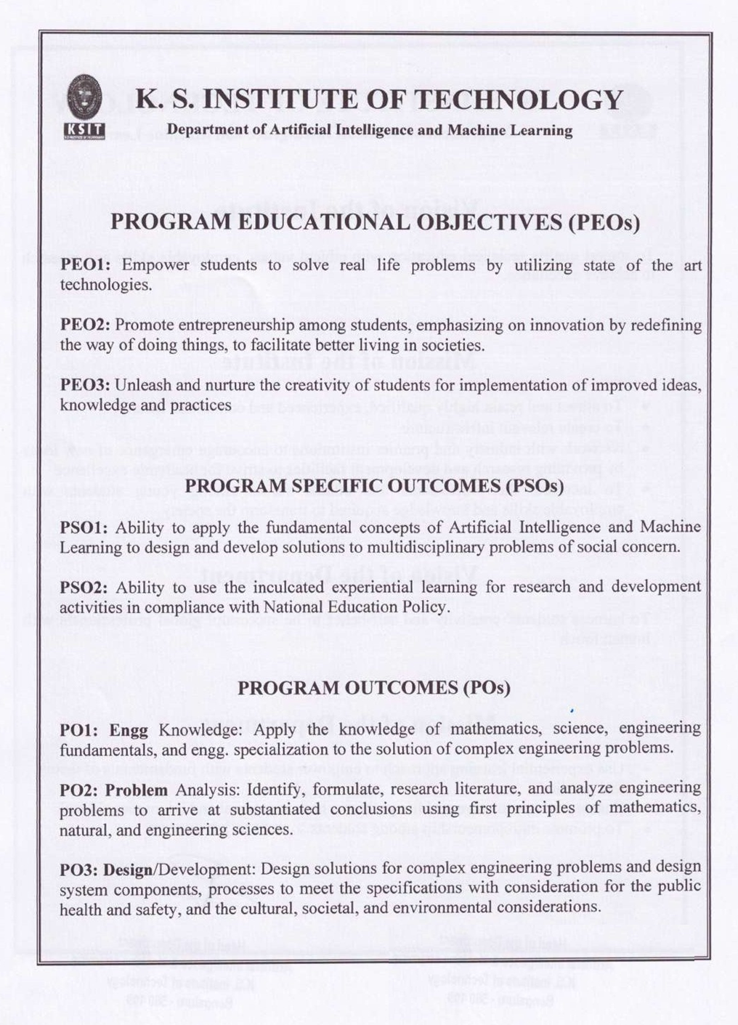
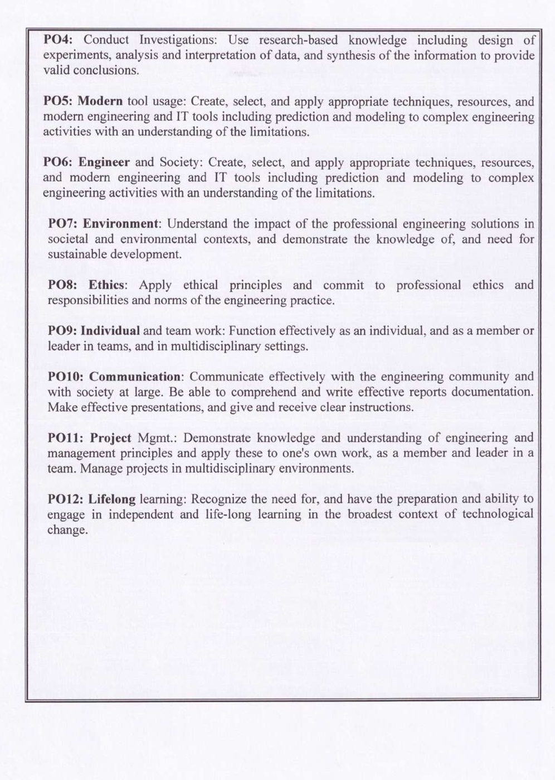

Sl.N O | Experiments
1 | Develop a c program to implement the Process system calls (fork (), exec(), wait(), create process, terminate process)
2 | Simulate the following CPU scheduling algorithms to find turnaround time and waiting time a) FCFS  b) SJF c) Round Robin d) Priority.
3 | Develop a C program to simulate producer-consumer problem using semaphores.
4 | Develop a C program which demonstrates interprocess communication between a reader process and a writer process. Use mkfifo, open, read, write and close APIs in your program.
5 | Develop a C program to simulate Bankers Algorithm for DeadLock Avoidance.
6 | Develop a C program to simulate the following contiguous memory allocation Techniques:  a) Worst fit b) Best fit c) First fit.  https://avanthioslab.blogspot.com/2016/09/a-worst-fit-b-best-fit-c-first-fit.html
7 | Develop a C program to simulate page replacement algorithms:  a) FIFO b) LRU
8 | Simulate following File Organization Techniques  a) Single level directory b) Two level directory
9 | Develop a C program to simulate the Linked file allocation strategies.
10 | Develop a C program to simulate SCAN disk scheduling algorithm.
Course outcomes (Course Skill Set):
At the end of the course, the student will be able to:
CO 1. Explain the structure and functionality of operating system
CO 2. Apply appropriate CPU scheduling algorithms for the given problem.
CO 3. Analyse the various techniques for process synchronization and deadlock handling. CO 4. Apply the various techniques for memory management
CO 5. Explain file and secondary storage management strategies. CO 6. Describe the need for information protection mechanisms
mentioned in 22OB4.2. The first test at the end of 40-50% coverage of the syllabus and the second test after covering 85-90% of the syllabus.
- Scaled-down marks of the sum of two tests and other assessment methods will be CIE marks for the theory component of IPCC (that is for 25 marks).
- The student has to secure 40% of 25 marks to qualify in the CIE of the theory component of IPCC.
CIE for the practical component of the IPCC

- 15 marks for the conduction of the experiment and preparation of laboratory record, and 10 marks for the test to be conducted after the completion of all the laboratory sessions.
- On completion of every experiment/program in the laboratory, the students shall be evaluated including viva-voce and marks shall be awarded on the same day.
- The CIE marks awarded in the case of the Practical component shall be based on the continuous evaluation of the laboratory report. Each experiment report can be evaluated for 10 marks. Marks of all experiments’ write-ups are added and scaled down to 15 marks.
- The laboratory test (duration 02/03 hours) after completion of all the experiments shall be conducted for 50 marks and scaled down to 10 marks.
- Scaled-down marks of write-up evaluations and tests added will be CIE marks for the laboratory component of IPCC for 25 marks.
- The student has to secure 40% of 25 marks to qualify in the CIE of the practical component of the IPCC.
SEE for IPCC

Suggested Learning Resources:
Textbooks
1. Abraham Silberschatz, Peter Baer Galvin, Greg Gagne, Operating System Principles 8th edition, Wiley-India, 2015
Reference Books
- Ann McHoes Ida M Fylnn, Understanding Operating System, Cengage Learning, 6th Edition
- D.M Dhamdhere, Operating Systems: A Concept Based Approach 3rd Ed, McGraw- Hill, 2013.
- P.C.P. Bhatt, An Introduction to Operating Systems: Concepts and Practice 4th Edition, PHI(EEE), 2014.
- William Stallings Operating Systems: Internals and Design Principles, 6th Edition, Pearson.

Table of Content

Sl. No. | Content
1 | Develop a c program to implement the Process system calls (fork (), exec(), wait(), create process, terminate process)
2 | Simulate the following CPU scheduling algorithms to find turnaround time and waiting time a) FCFS  b) SJF c) Round Robin d) Priority.
3 | Develop a C program to simulate producer-consumer problem using semaphores.
4 | Develop a C program which demonstrates interprocess communication between a reader process and a writer process. Use mkfifo, open, read, write and close APIs in your program.
5 | Develop a C program to simulate Bankers Algorithm for DeadLock Avoidance.
6 | Develop a C program to simulate the following contiguous memory allocation Techniques:  a) Worst fit b) Best fit c) First fit.
7 | Develop a C program to simulate page replacement algorithms:  a) FIFO b) LRU
8 | Simulate following File Organization Techniques  a) Single level directory b) Two level directory
9 | Develop a C program to simulate the Linked file allocation strategies.
10 | Develop a C program to simulate SCAN disk scheduling algorithm.

Program-1

Develop a c program to implement the Process system calls (fork (), exec (), wait (), create process, terminate process)

#include<stdio.h> // printf()
#include<stdlib.h> // exit()
#include<sys/types.h> // pid_t
#include<sys/wait.h> // wait()
#include<unistd.h> // fork

int main(int argc, char **argv)
{
pid_t pid;
pid = fork();
if(pid==0)
{
printf("It is the child process and pid is %d\n",getpid());
int i=0;
for(i=0;i<8;i++)
{
printf("%d\n",i);
}
exit(0);
}
else if(pid > 0)
{
printf("It is the parent process and pid is %d\n",getpid());
int status;
wait(&status);
printf("Child is reaped\n");
}
else
{
printf("Error in forking..\n");
exit(EXIT_FAILURE);
}
return 0;
}

Output:

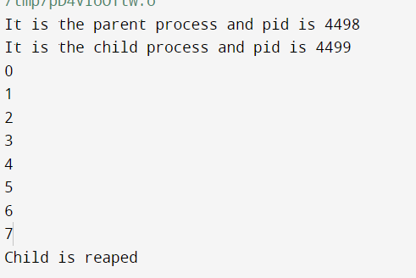

Program-2

Simulate the following CPU scheduling algorithms to find turnaround time and waiting time

- FCFS
#include<stdio.h>
int main()
{
int n,bt[20],wt[20],tat[20],avwt=0,avtat=0,i,j;
printf("Enter total number of processes(maximum 20): ");
scanf("%d",&n);
printf("\nEnter Process Burst Time:\n");
for(i=0;i<n;i++)
{
printf("P[%d]: ",i+1);
scanf("%d",&bt[i]);
}
wt[0]=0;
for(i=1;i<n;i++)
{
wt[i]=0;
for(j=0;j<i;j++)
wt[i]+=bt[j];
}

printf("\nProcess\t\tBurst Time\tWaiting Time\tTurnaround Time");
//calculating turnaround time
for(i=0;i<n;i++)
{
tat[i]=bt[i]+wt[i];
avwt+=wt[i];
avtat+=tat[i];
printf("\nP[%d]\t\t%d\t\t%d\t\t%d",i+1,bt[i],wt[i],tat[i]);
}
avwt/=i;
avtat/=i;
printf("\n\nAverage Waiting Time:%d",avwt);
printf("\nAverage Turnaround Time:%d",avtat);
return 0;
}

Output:

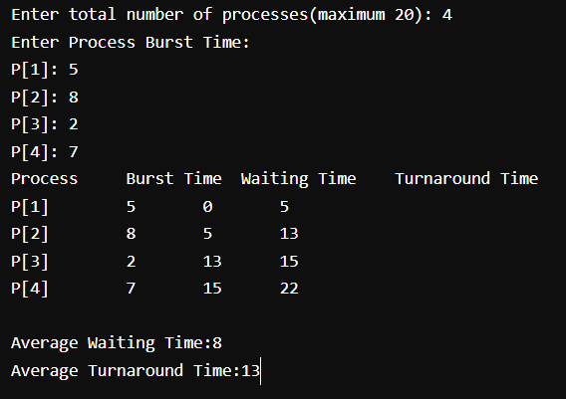

- SJF

#include<stdio.h>
int main()
{
int bt[20],p[20],wt[20],tat[20],i,j,n,total=0,pos,temp;
float avg_wt,avg_tat;
printf("Enter number of process: ");
scanf("%d",&n);
printf("\nEnter Burst Time:\n");
for(i=0;i<n;i++)
{
printf("p%d: ",i+1);
scanf("%d",&bt[i]);
p[i]=i+1;
}
for(i=0;i<n;i++)
{ pos=i;
for(j=i+1;j<n;j++)
{ if(bt[j]<bt[pos])
pos=j;
}
temp=bt[i];
bt[i]=bt[pos];
bt[pos]=temp;
temp=p[i];
p[i]=p[pos];
p[pos]=temp;
}
wt[0]=0;
for(i=1;i<n;i++)
{ wt[i]=0;
for(j=0;j<i;j++)
wt[i]+=bt[j];
total+=wt[i];
}
avg_wt=(float)total/n;
total=0;
printf("\nProcess\t Burst Time \tWaiting Time\tTurnaround Time");
for(i=0;i<n;i++)
{ tat[i]=bt[i]+wt[i];
total+=tat[i];

printf("\np%d\t\t %d\t\t %d\t\t\t%d",p[i],bt[i],wt[i],tat[i]);
}
avg_tat=(float)total/n;
printf("\n\nAverage Waiting Time=%f",avg_wt);
printf("\nAverage Turnaround Time=%f\n",avg_tat);
return 0;
}

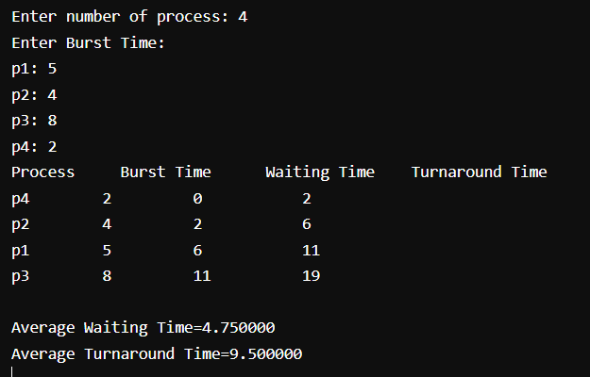
Output:

- Round Robin

#include<stdio.h>
int main()
{
int count,j,n,time,remain,flag=0,time_quantum;
int wait_time=0,turnaround_time=0,at[10],bt[10],rt[10];
printf("Enter Total Process:\t ");
scanf("%d",&n);
remain=n;
for(count=0;count<n;count++)
{
printf("Enter Arrival Time and Burst Time for Process Process Number %d :",count+1);
scanf("%d",&at[count]);
scanf("%d",&bt[count]);
rt[count]=bt[count];
}
printf("Enter Time Quantum:\t");
scanf("%d",&time_quantum);
printf("\n\nProcess\t|Turnaround Time|Waiting Time\n\n");
for(time=0,count=0;remain!=0;)
{
if(rt[count]<=time_quantum && rt[count]>0)
{
time+=rt[count];
rt[count]=0;
flag=1;
}
else if(rt[count]>0)

{
rt[count]-=time_quantum;
time+=time_quantum;
}
if(rt[count]==0 && flag==1)
{
remain--;
printf("P[%d]\t|\t%d\t|\t%d\n",count+1,time-at[count],time-at[count]-bt[count]);
wait_time+=time-at[count]-bt[count];
turnaround_time+=time-at[count];
flag=0;
}
if(count==n-1)
count=0;
else if(at[count+1]<=time)
count++;
else
count=0;
}
printf("\nAverage Waiting Time= %f\n",wait_time*1.0/n);
printf("Avg Turnaround Time = %f",turnaround_time*1.0/n);

return 0;
}

Output:

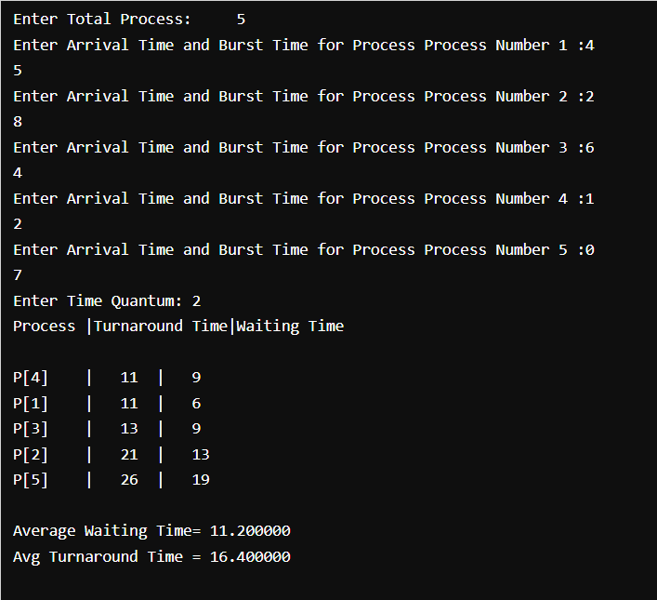

- Priority

#include<stdio.h>

int main()
{
int bt[20],p[20],wt[20],tat[20],pr[20],i,j,n,total=0,pos,temp,avg_wt,avg_tat;
printf("Enter Total Number of Process:");
scanf("%d",&n);

printf("\nEnter Burst Time and Priority\n");
for(i=0;i<n;i++)
{
printf("\nP[%d]\n",i+1);
printf("Burst Time:");
scanf("%d",&bt[i]);
printf("Priority:");
scanf("%d",&pr[i]);
p[i]=i+1;
}

for(i=0;i<n;i++)
{
pos=i;
for(j=i+1;j<n;j++)
{
if(pr[j]<pr[pos])
pos=j;
}

temp=pr[i];
pr[i]=pr[pos];
pr[pos]=temp;

temp=bt[i];
bt[i]=bt[pos];
bt[pos]=temp;

temp=p[i];
p[i]=p[pos];
p[pos]=temp;
}

wt[0]=0;
for(i=1;i<n;i++)
{
wt[i]=0;

for(j=0;j<i;j++)
wt[i]+=bt[j];

total+=wt[i];
}

avg_wt=total/n;
total=0;

printf("\nProcess\t Burst Time \tWaiting Time\tTurnaround Time");
for(i=0;i<n;i++)
{

tat[i]=bt[i]+wt[i];
total+=tat[i];
printf("\nP[%d]\t\t %d\t\t %d\t\t\t%d",p[i],bt[i],wt[i],tat[i]);
}

avg_tat=total/n;
printf("\n\nAverage Waiting Time=%d",avg_wt);
printf("\nAverage Turnaround Time=%d\n",avg_tat);

return 0;
}

Output:

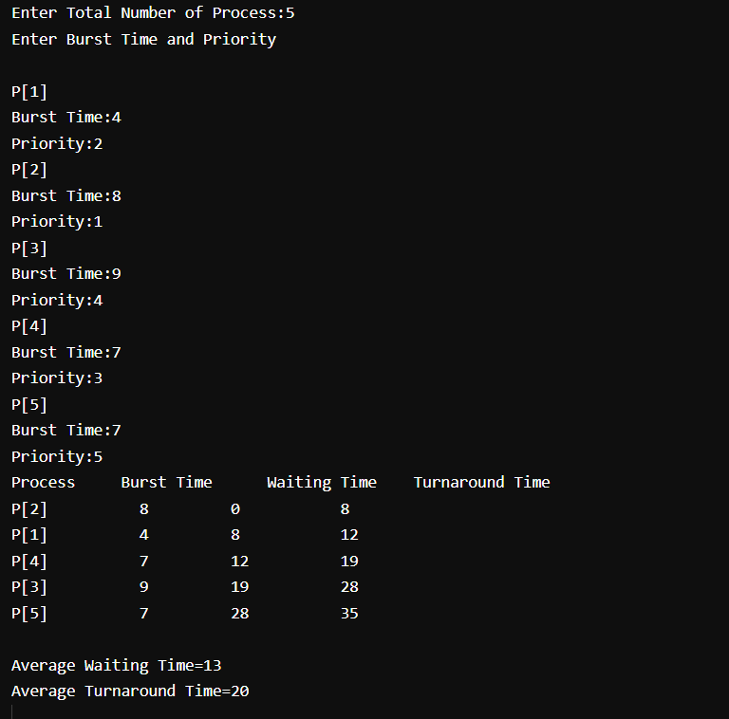

Program-3

Develop a C program to simulate producer-consumer problem using semaphores.

#include<stdio.h>
void main()
{
int buffer[10], bufsize, in, out, produce, consume, choice=0;
in = 0;
out = 0;
bufsize = 10;
while(choice !=3)
{
printf("\n 1. Produce \t 2. Consume \t3. Exit");
printf("\n Enter your choice: ");
scanf("%d", &choice);
switch(choice) {
case 1: if((in+1)%bufsize==out)
printf("\n Buffer is Full");
else
{
printf("\nEnter the value: ");
scanf("%d", &produce);
buffer[in] = produce;
in = (in+1)%bufsize;
}
break;
case 2: if(in == out)
printf("\nBuffer is Empty");
else
{
consume = buffer[out];
printf("\nThe consumed value is %d", consume);
out = (out+1)%bufsize;
}
break;
} } }

Output:

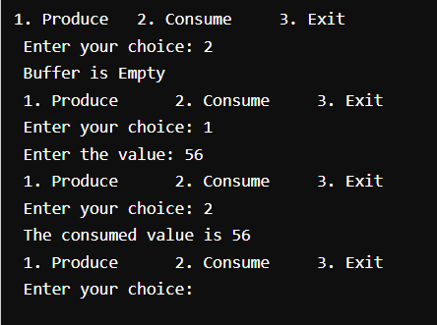

Program-4

Develop a C program which demonstrates inter-process communication between a reader process and a writer process. Use mkfifo, open, read, write and close APIs in your program.

/*Writer Process*/

#include <stdio.h>
#include <fcntl.h>
#include <sys/stat.h>
#include <sys/types.h>
#include <unistd.h>
int main()
{
int fd;
char buf[1024];
/* create the FIFO (named pipe) */
char * myfifo = "/tmp/myfifo";
mkfifo(myfifo, 0666);
printf("Run Reader process to read the FIFO File\n");
fd = open(myfifo, O_WRONLY);
write(fd,"Hi", sizeof("Hi"));
/* write "Hi" to the FIFO */
close(fd);
unlink(myfifo); /* remove the FIFO */
return 0;
}

/* Reader Process*/

#include <fcntl.h>
#include <sys/stat.h>
#include <sys/types.h>
#include <unistd.h>
#include <stdio.h>
#define MAX_BUF 1024
int main()
{
int fd;
/* A temp FIFO file is not created in reader */
char *myfifo = "/tmp/myfifo";
char buf[MAX_BUF];
/* open, read, and display the message from the FIFO */
fd = open(myfifo, O_RDONLY);
read(fd, buf, MAX_BUF);
printf("Writer: %s\n", buf);
close(fd);
return 0;
}

Instructions for Execution:

- Run Reader Process
- Then Run Writer Process

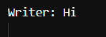

Program-5

Develop a C program to simulate Bankers Algorithm for DeadLock Avoidance.

#include <stdio.h>
#include <stdlib.h>
int main()
{
int Max[10][10], need[10][10], alloc[10][10], avail[10], completed[10], safeSequence[10];
int p, r, i, j, process, count;
count = 0;

printf("Enter the no of processes : ");
scanf("%d", &p);

for(i = 0; i< p; i++)
completed[i] = 0;

printf("\n\nEnter the no of resources : ");
scanf("%d", &r);

printf("\n\nEnter the Max Matrix for each process : ");
for(i = 0; i < p; i++)
{
printf("\nFor process %d : ", i + 1);
for(j = 0; j < r; j++)
scanf("%d", &Max[i][j]);
}

printf("\n\nEnter the allocation for each process : ");
for(i = 0; i < p; i++)
{
printf("\nFor process %d : ",i + 1);
for(j = 0; j < r; j++)
scanf("%d", &alloc[i][j]);
}

printf("\n\nEnter the Available Resources : ");
for(i = 0; i < r; i++)
scanf("%d", &avail[i]);

for(i = 0; i < p; i++)

for(j = 0; j < r; j++)
need[i][j] = Max[i][j] - alloc[i][j];

do
{
printf("\n Max matrix:\tAllocation matrix:\n");

for(i = 0; i < p; i++)
{
for( j = 0; j < r; j++)
printf("%d ", Max[i][j]);
printf("\t\t");

for( j = 0; j < r; j++)

printf("%d ", alloc[i][j]);
printf("\n");
}

process = -1;

for(i = 0; i < p; i++)
{
if(completed[i] == 0)//if not completed
{
process = i ;
for(j = 0; j < r; j++)
{
if(avail[j] < need[i][j])
{
process = -1;
break;
}
}
}
if(process != -1)
break;
}

if(process != -1)
{
printf("\nProcess %d runs to completion!", process + 1);
safeSequence[count] = process + 1;
count++;
for(j = 0; j < r; j++)
{
avail[j] += alloc[process][j];
alloc[process][j] = 0;
Max[process][j] = 0;
completed[process] = 1;
}
}
}
while(count != p && process != -1);

if(count == p)
{
printf("\nThe system is in a safe state!!\n");
printf("Safe Sequence : < ");
for( i = 0; i < p; i++)
printf("%d ", safeSequence[i]);
printf(">\n");
}
else
printf("\nThe system is in an unsafe state!!");

}

Output:

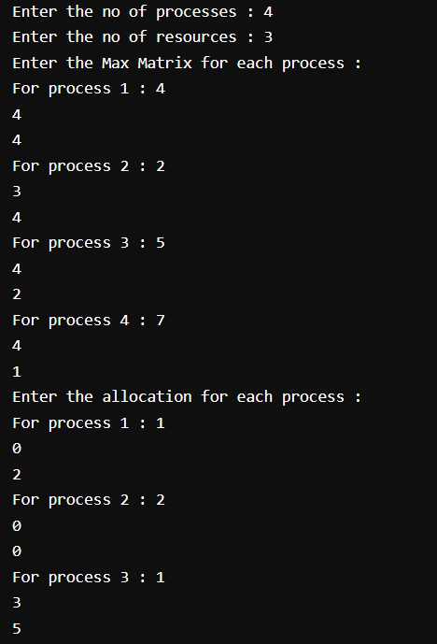
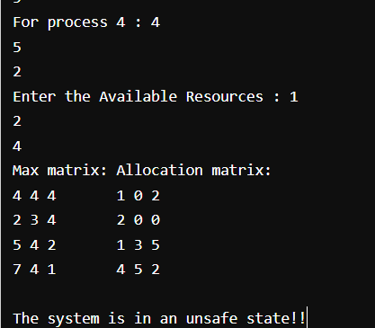

Program-6

Develop a C program to simulate the following contiguous memory allocation Techniques

WORST-FIT
#include<stdio.h>
#include<conio.h>
#define max 25
void main()
{
int frag[max],b[max],f[max],i,j,nb,nf,temp,highest=0;
static int bf[max],ff[max];
clrscr();

printf("\n\tMemory Management Scheme - Worst Fit");
printf("\nEnter the number of blocks:");
scanf("%d",&nb);
printf("Enter the number of files:");
scanf("%d",&nf);
printf("\nEnter the size of the blocks:-\n");
for(i=1;i<=nb;i++)
{
printf("Block %d:",i);
scanf("%d",&b[i]);
}
printf("Enter the size of the files :-\n");
for(i=1;i<=nf;i++)
{
printf("File %d:",i);
scanf("%d",&f[i]);
}
for(i=1;i<=nf;i++)
{
for(j=1;j<=nb;j++)
{
if(bf[j]!=1) //if bf[j] is not allocated
{
temp=b[j]-f[i];
if(temp>=0)
if(highest<temp)
{
ff[i]=j;
highest=temp;
}
}
frag[i]=highest;
bf[ff[i]]=1;
highest=0;
}
ff[i]=j;
highest=temp;
}
printf("\nFile_no:\tFile_size :\tBlock_no:\tBlock_size:\tFragement");
for(i=1;i<=nf;i++)
printf("\n%d\t\t%d\t\t%d\t\t%d\t\t%d",i,f[i],ff[i],b[ff[i]],frag[i]);
getch();
}
- Worst fit

#include<stdio.h>
int main()
{
int fragments[10], blocks[10], files[10];
int m, n, number_of_blocks, number_of_files, temp, top = 0;
static int block_arr[10], file_arr[10];
printf("\nEnter the Total Number of Blocks:\t");
scanf("%d",&number_of_blocks);
printf("Enter the Total Number of Files:\t");
scanf("%d",&number_of_files);
printf("\nEnter the Size of the Blocks:\n");
for(m = 0; m < number_of_blocks; m++)
{
printf("Block No.[%d]:\t", m + 1);
scanf("%d", &blocks[m]);
}
printf("Enter the Size of the Files:\n");
for(m = 0; m < number_of_files; m++)
{
printf("File No.[%d]:\t", m + 1);
scanf("%d", &files[m]);
}
for(m = 0; m < number_of_files; m++)
{
for(n = 0; n < number_of_blocks; n++)
{
if(block_arr[n] != 1)
{
temp = blocks[n] - files[m];
if(temp >= 0)
{
if(top < temp)
{
file_arr[m] = n;
top = temp;
}
}
}
fragments[m] = top;
block_arr[file_arr[m]] = 1;
top = 0;
}
}
printf("\nFile Number\tFile Size\tBlock Number\tBlock Size\tFragment");
for(m = 0; m < number_of_files; m++)
{
printf("\n%d\t\t%d\t\t%d\t\t%d\t\t%d", m, files[m], file_arr[m], blocks[file_arr[m]], fragments[m]);
}
printf("\n");

return 0;
}

Output:

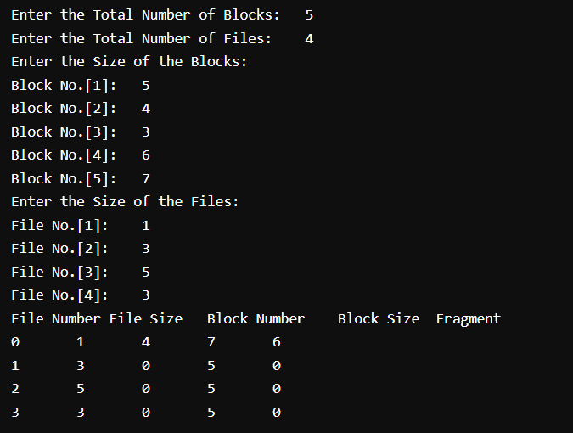

Best Fit

#include<stdio.h>
#include<conio.h>
#define max 25
void main()
{
int frag[max],b[max],f[max],i,j,nb,nf,temp,highest=0;
static int bf[max],ff[max];
clrscr();

printf("\n\tMemory Management Scheme - Worst Fit");
printf("\nEnter the number of blocks:");
scanf("%d",&nb);
printf("Enter the number of files:");
scanf("%d",&nf);
printf("\nEnter the size of the blocks:-\n");
for(i=1;i<=nb;i++)
{
printf("Block %d:",i);
scanf("%d",&b[i]);
}
printf("Enter the size of the files :-\n");
for(i=1;i<=nf;i++)
{
printf("File %d:",i);
scanf("%d",&f[i]);
}
for(i=1;i<=nf;i++)
{

for(j=1;j<=nb;j++)
{
if(bf[j]!=1) //if bf[j] is not allocated
{
temp=b[j]-f[i];
if(temp>=0)
if(highest<temp)
{
ff[i]=j;
highest=temp;

}
}
frag[i]=highest;
bf[ff[i]]=1;
highest=0;
}

ff[i]=j;
highest=temp;
}

printf("\nFile_no:\tFile_size :\tBlock_no:\tBlock_size:\tFragement");
for(i=1;i<=nf;i++)
printf("\n%d\t\t%d\t\t%d\t\t%d\t\t%d",i,f[i],ff[i],b[ff[i]],frag[i]);
getch();
}

- Best Fit

#include<stdio.h>

void main()
{
int fragment[20],b[20],p[20],i,j,nb,np,temp,lowest=9999;
static int barray[20],parray[20];

printf("\n\t\t\tMemory Management Scheme - Best Fit");
printf("\nEnter the number of blocks:");
scanf("%d",&nb);
printf("Enter the number of processes:");
scanf("%d",&np);

printf("\nEnter the size of the blocks:-\n");
for(i=1;i<=nb;i++)
{
printf("Block no.%d:",i);
scanf("%d",&b[i]);
}

printf("\nEnter the size of the processes :-\n");
for(i=1;i<=np;i++)
{
printf("Process no.%d:",i);
scanf("%d",&p[i]);
}

for(i=1;i<=np;i++)
{
for(j=1;j<=nb;j++)
{
if(barray[j]!=1)
{
temp=b[j]-p[i];
if(temp>=0)
if(lowest>temp)
{
parray[i]=j;
lowest=temp;
}
}
}

fragment[i]=lowest;
barray[parray[i]]=1;
lowest=10000;
}

printf("\nProcess_no\tProcess_size\tBlock_no\tBlock_size\tFragment");
for(i=1;i<=np && parray[i]!=0;i++)
printf("\n%d\t\t%d\t\t%d\t\t%d\t\t%d",i,p[i],parray[i],b[parray[i]],fragment[i]);
}

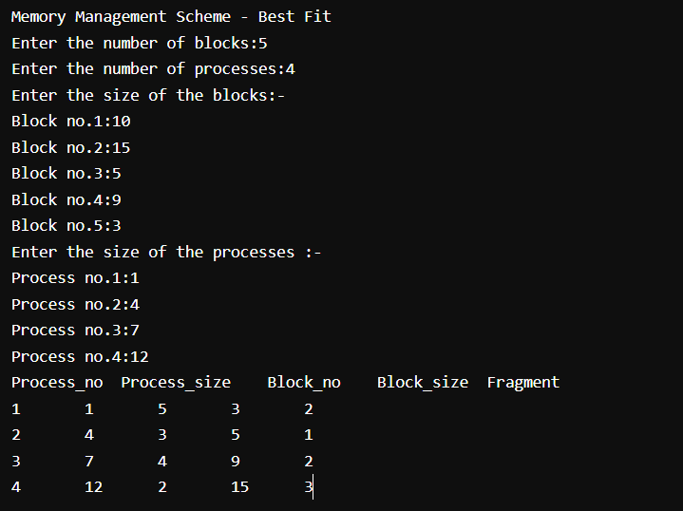

First Fit
#include<stdio.h>
#include<conio.h>
#define max 25
void main()
{
int frag[max],b[max],f[max],i,j,nb,nf,temp;
static int bf[max],ff[max];
clrscr();
printf("\n\tMemory Management Scheme - First Fit");
printf("\nEnter the number of blocks:");
scanf("%d",&nb);
printf("Enter the number of files:");
scanf("%d",&nf);
printf("\nEnter the size of the blocks:-\n");
for(i=1;i<=nb;i++)
{
printf("Block %d:",i);
scanf("%d",&b[i]);
}
printf("Enter the size of the files :-\n");
for(i=1;i<=nf;i++)
{
printf("File %d:",i);
scanf("%d",&f[i]);
}
for(i=1;i<=nf;i++)
{
for(j=1;j<=nb;j++)
{
if(bf[j]!=1)
{
temp=b[j]-f[i];
if(temp>=0)
{
ff[i]=j;
break;
}
}
}
frag[i]=temp; bf[ff[i]]=1;
}
printf("\nFile_no:\tFile_size :\tBlock_no:\tBlock_size:\tFragement"); for(i=1;i<=nf;i++)
printf("\n%d\t\t%d\t\t%d\t\t%d\t\t%d",i,f[i],ff[i],b[ff[i]],frag[i];
getch();
}

- First Fit
#include<stdio.h>
#define max 25
void main()
{
int frag[max],b[max],f[max],i,j,nb,nf,temp,highest=0;
static int bf[max],ff[max];
printf("\n\tMemory Management Scheme - First Fit");
printf("\nEnter the number of blocks:");
scanf("%d",&nb);
printf("Enter the number of files:");
scanf("%d",&nf);
printf("\nEnter the size of the blocks:-\n");
for(i=1;i<=nb;i++)
{
printf("Block %d:",i);
scanf("%d",&b[i]);
}
printf("Enter the size of the files :-\n");
for(i=1;i<=nf;i++)
{
printf("File %d:",i);
scanf("%d",&f[i]);
}
for(i=1;i<=nf;i++)
{
for(j=1;j<=nb;j++)
{
if(bf[j]!=1) //if bf[j] is not allocated
{
temp=b[j]-f[i];
if(temp>=0)
if(highest<temp)
{
ff[i]=j;
highest=temp;
}
}
}
frag[i]=highest;
bf[ff[i]]=1;
highest=0;
}
printf("\nFile_no:\tFile_size :\tBlock_no:\tBlock_size:\tFragement");
for(i=1;i<=nf;i++)
printf("\n%d\t\t%d\t\t%d\t\t%d\t\t%d",
i,f[i],ff[i],b[ff[i]],frag[i]);
}

Output:

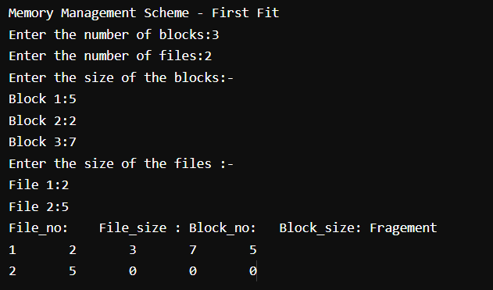

Program-7

Develop a C program to simulate page replacement algorithms

- FIFO

#include<stdio.h>
int main()
{
int i,j,n,a[50],frame[10],no,k,avail,count=0;
printf("\n ENTER THE NUMBER OF PAGES:\n");
scanf("%d",&n);
printf("\n ENTER THE PAGE NUMBER :\n");
for(i=1;i<=n;i++)
scanf("%d",&a[i]);
printf("\n ENTER THE NUMBER OF FRAMES :");
scanf("%d",&no);
for(i=0;i<no;i++)
frame[i]= -1;
j=0;
printf("\tref string\t page frames\n");
for(i=1;i<=n;i++)
{
printf("%d\t\t",a[i]);
avail=0;
for(k=0;k<no;k++)
if(frame[k]==a[i])
avail=1;
if (avail==0)
{
frame[j]=a[i];
j=(j+1)%no;
count++;
for(k=0;k<no;k++)
printf("%d\t",frame[k]);
}
printf("\n");
}
printf("Page Fault Is %d",count);
return 0;
}

Output:

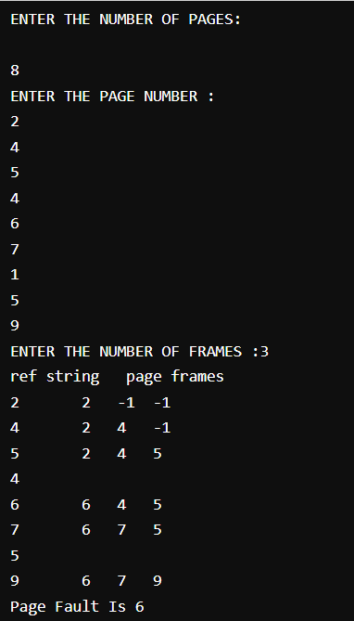

- LRU

#include<stdio.h>
int i,j,nof,nor,flag=0,ref[50],frm[50],pf=0,victim=-1;
int recent[10],lrucal[50],count=0;
int lruvictim();
void main()
{
printf("\n\t\t\t LRU PAGE REPLACEMENT ALGORITHM");
printf("\n Enter no.of Frames....");
scanf("%d",&nof);
printf(" Enter no.of reference string..");
scanf("%d",&nor);
printf("\n Enter reference string..");
for(i=0;i<nor;i++)
scanf("%d",&ref[i]);
printf("\n\n\t\t LRU PAGE REPLACEMENT ALGORITHM ");
printf("\n\t The given reference string:");
printf("\n………………………………..");
for(i=0;i<nor;i++)
printf("%4d",ref[i]);
for(i=1;i<=nof;i++)
{
frm[i]=-1;
lrucal[i]=0;
} for(i=0;i<10;i++)
recent[i]=0;
printf("\n");
for(i=0;i<nor;i++)

{
flag=0;

printf("\n\t Reference NO %d->\t",ref[i]);

for(j=0;j<nof;j++)
{
if(frm[j]==ref[i])
{
flag=1;
break;
}
}
if(flag==0)
{
count++;
if(count<=nof)
victim++;
else
victim=lruvictim();
pf++;
frm[victim]=ref[i];
for(j=0;j<nof;j++)
printf("%4d",frm[j]);
}
recent[ref[i]]=i;
}
printf("\n\n\t No.of page faults...%d",pf);
}
int lruvictim()
{
int i,j,temp1,temp2;
for(i=0;i<nof;i++)
{
temp1=frm[i];
lrucal[i]=recent[temp1];
}
temp2=lrucal[0];
for(j=1;j<nof;j++)
{
if(temp2>lrucal[j])
temp2=lrucal[j];
}
for(i=0;i<nof;i++)
if(ref[temp2]==frm[i])
return i;
return 0;
}

Output:

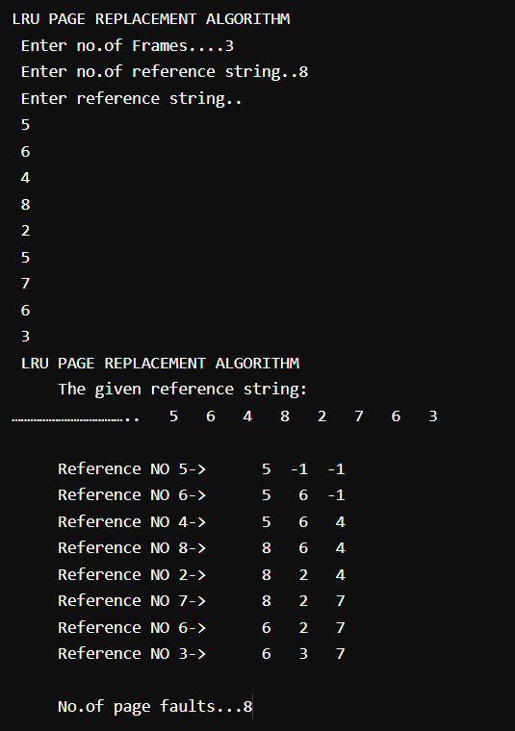

Program-8

Simulate following File Organization Techniques

- Single level directory

#include<stdlib.h>
#include<string.h>
#include<stdio.h>
struct
{
char dname[10],fname[10][10];
int fcnt;
}dir;
void main()
{
int i,ch;
char f[30];
dir.fcnt = 0;
printf("\nEnter name of directory -- ");
scanf("%s", dir.dname);
while(1)
{
printf("\n\n1. Create File\t2. Delete File\t3. Search File \n 4. Display Files\t5. Exit\nEnter your choice -- ");
scanf("%d",&ch);
switch(ch)
{
case 1: printf("\nEnter the name of the file -- ");
scanf("%s",dir.fname[dir.fcnt]);
dir.fcnt++;
break;
case 2: printf("\nEnter the name of the file -- ");
scanf("%s",f);
for(i=0;i<dir.fcnt;i++)
{
if(strcmp(f, dir.fname[i])==0)
{
printf("File %s is deleted ",f);
strcpy(dir.fname[i],dir.fname[dir.fcnt-1]); break; } }
if(i==dir.fcnt) printf("File %s not found",f);
else
dir.fcnt--;
break;
case 3: printf("\nEnter the name of the file -- ");
scanf("%s",f);
for(i=0;i<dir.fcnt;i++)
{
if(strcmp(f, dir.fname[i])==0)
{
printf("File %s is found ", f);
break;
}
}
if(i==dir.fcnt)

printf("File %s not found",f);
break;
case 4: if(dir.fcnt==0)
printf("\nDirectory Empty");
else
{
printf("\nThe Files are -- ");
for(i=0;i<dir.fcnt;i++)
printf("\t%s",dir.fname[i]);
}
break;
default: exit(0);
}
}
}

Output:

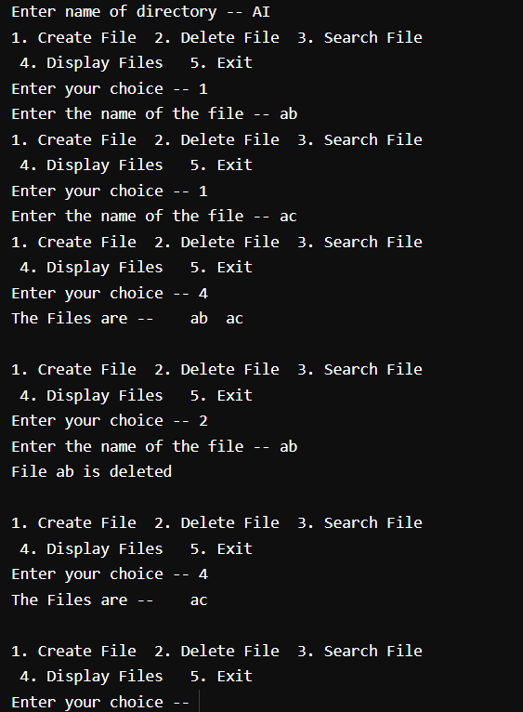

- Two-Level Directory

#include<string.h>
#include<stdlib.h>
#include<stdio.h>

struct
{
char dname[10],fname[10][10];
int fcnt;
}dir[10];
void main()
{
int i,ch,dcnt,k;
char f[30], d[30];
dcnt=0;
while(1)
{
printf("\n\n1. Create Directory\t2. Create File\t3. Delete File");
printf("\n4. Search File\t\t5. Display\t6. Exit\tEnter your choice -- ");
scanf("%d",&ch);
switch(ch)
{
case 1: printf("\nEnter name of directory -- ");
scanf("%s", dir[dcnt].dname);
dir[dcnt].fcnt=0;
dcnt++;
printf("Directory created");
break;
case 2: printf("\nEnter name of the directory -- ");
scanf("%s",d);
for(i=0;i<dcnt;i++)
if(strcmp(d,dir[i].dname)==0)
{
printf("Enter name of the file -- ");
scanf("%s",dir[i].fname[dir[i].fcnt]);
printf("File created");
break;
}
if(i==dcnt)
printf("Directory %s not found",d);
break;
case 3: printf("\nEnter name of the directory -- ");
scanf("%s",d);
for(i=0;i<dcnt;i++)
{
if(strcmp(d,dir[i].dname)==0)
{
printf("Enter name of the file -- ");
scanf("%s",f);
for(k=0;k<dir[i].fcnt;k++)
{
if(strcmp(f, dir[i].fname[k])==0)
{
printf("File %s is deleted ",f);

dir[i].fcnt--;

strcpy(dir[i].fname[k],dir[i].fname[dir[i].fcnt]);
goto jmp;
}
}
printf("File %s not found",f);
goto jmp;
}
}
printf("Directory %s not found",d);
jmp : break;
case 4: printf("\nEnter name of the directory -- ");
scanf("%s",d);
for(i=0;i<dcnt;i++)
{
if(strcmp(d,dir[i].dname)==0)
{
printf("Enter the name of the file -- ");
scanf("%s",f);
for(k=0;k<dir[i].fcnt;k++)
{
if(strcmp(f, dir[i].fname[k])==0)
{
printf("File %s is found ",f);
goto jmp1;
}
}
printf("File %s not found",f);
goto jmp1;
}
}
printf("Directory %s not found",d);
jmp1: break;
case 5: if(dcnt==0)
printf("\nNo Directory's ");
else
{
printf("\nDirectory\tFiles");
for(i=0;i<dcnt;i++)
{
printf("\n%s\t\t",dir[i].dname);
for(k=0;k<dir[i].fcnt;k++)
printf("\t%s",dir[i].fname[k]);
}
}
break;
default:exit(0);
}
}
}

Output:

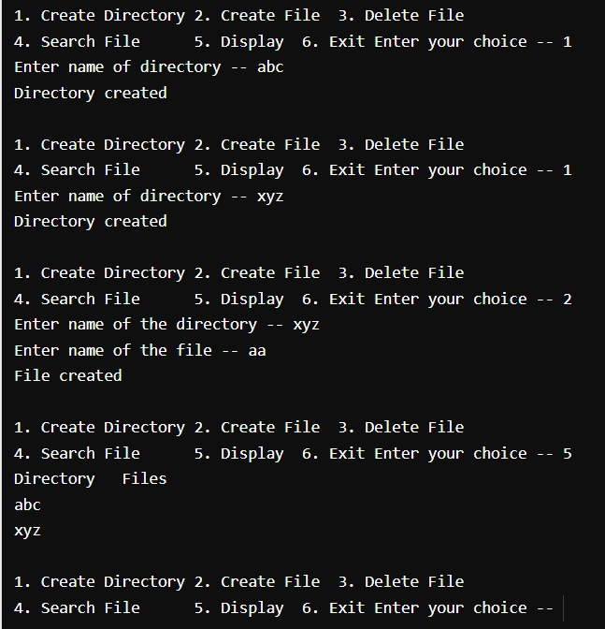

Program-9

Develop a C program to simulate the Linked file allocation strategies.

#include<stdio.h>
#include<conio.h>
#include<stdlib.h>
void main()
{
int f[50], p,i, st, len, j, c, k, a;
clrscr();
for(i=0;i<50;i++)
f[i]=0;
printf("Enter how many blocks already allocated: ");
scanf("%d",&p);
printf("Enter blocks already allocated: ");
for(i=0;i<p;i++)
{
scanf("%d",&a);
f[a]=1;
}
x: printf("Enter index starting block and length: ");
scanf("%d%d", &st,&len);
k=len;
if(f[st]==0)
{
for(j=st;j<(st+k);j++)
{
if(f[j]==0)
{
f[j]=1;
printf("%d-------->%d\n",j,f[j]);
}
else
{
printf("%d Block is already allocated \n",j);
k++;
}
}
}
else
printf("%d starting block is already allocated \n",st);
printf("Do you want to enter more file(Yes - 1/No - 0)");
scanf("%d", &c);
if(c==1)
goto x;
else
exit(0);
getch();
}

Output:

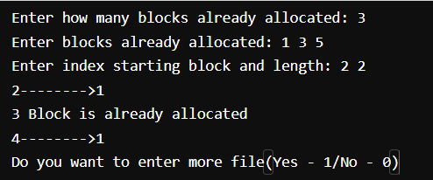

Program-10

Develop a C program to simulate SCAN disk scheduling algorithm.

#include <stdio.h>
int request[50];
int SIZE;
int pre;
int head;
int uptrack;
int downtrack;
struct max{
int up;
int down;
} kate[50];
int dist(int a, int b){
if (a > b)
return a - b;
return b - a;
}
void sort(int n){
int i, j;
for (i = 0; i < n - 1; i++){
for (j = 0; j < n - i - 1; j++){
if (request[j] > request[j + 1]){
int temp = request[j];
request[j] = request[j + 1];
request[j + 1] = temp;
}
}
}
j = 0;
i = 0;
while (request[i] != head){
kate[j].down = request[i];
j++;
i++;
}
downtrack = j;
i++;
j = 0;
while (i < n){
kate[j].up = request[i];
j++;
i++;
}
uptrack = j;
}
void scan(int n){
int i;
int seekcount = 0;
printf("SEEK SEQUENCE = ");
sort(n);

if (pre < head){

for (i = 0; i < uptrack; i++){

printf("%d ", head);
seekcount = seekcount + dist(head, kate[i].up);
head = kate[i].up;
}
for (i = downtrack - 1; i > 0; i--){
printf("%d ", head);
seekcount = seekcount + dist(head, kate[i].down);
head = kate[i].down;
}
}
else{
for (i = downtrack - 1; i >= 0; i--){
printf("%d ", head);
seekcount = seekcount + dist(head, kate[i].down);
head = kate[i].down;
}
for (i = 0; i < uptrack - 1; i++){
printf("%d ", head);
seekcount = seekcount + dist(head, kate[i].up);
head = kate[i].up;
}
}
printf(" %d\nTOTAL DISTANCE :%d", head, seekcount);
}
int main(){
int n, i;
printf("ENTER THE DISK SIZE :\n");
scanf("%d", &SIZE);
printf("ENTER THE NO OF REQUEST SEQUENCE :\n");
scanf("%d", &n);
printf("ENTER THE REQUEST SEQUENCE :\n");
for (i = 0; i < n; i++)
scanf("%d", &request[i]);
printf("ENTER THE CURRENT HEAD :\n");
scanf("%d", &head);
request[n] = head;
request[n + 1] = SIZE - 1;
request[n + 2] = 0;
printf("ENTER THE PRE REQUEST :\n");
scanf("%d", &pre);
scan(n + 3);
}

Output:

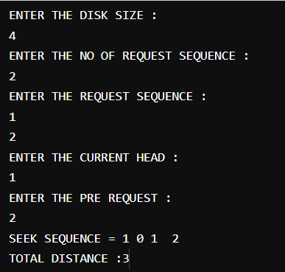

Viva Questions and Answers

1) Explain the main purpose of an operating system?
Operating systems exist for two main purposes. One is that it is designed to make sure a computer system performs well by managing its computational activities. Another is that it provides an environment for the development and execution of programs.

2) What is demand paging?
Demand paging is referred when not all of a process’s pages are in the RAM, then the OS brings the missing(and required) pages from the disk into the RAM.

3) What are the advantages of a multiprocessor system?
With an increased number of processors, there is a considerable increase in throughput. It can also save more money because they can share resources. Finally, overall reliability is increased as well.

4) What is kernel?
A kernel is the core of every operating system. It connects applications to the actual processing of data. It also manages all communications between software and hardware components to ensure usability and reliability.

WWW.VIDYARTHIPLUS.COM

WWW.VIDYARTHIPLUS.COM
V+ TEAM

allocation state if, for each Pi, the resources that the Pi can
still request can be satisfied by the currently available
resources plus the resources held by all the Pj, with j.
Explain briefly about, processor, assembler, compiler, loader, linker
and the functions executed by them.

What is virtual memory?
A virtual memory is hardware technique where the system appears
to have more memory that it actually does.
What is cache memory?
What is CPU Scheduler?

Selects from among the processes in memory that are ready to execute,
and allocates the CPU to one of them.
What is Throughput, Turnaround time, waiting time and Response time?

Throughput – number of processes that complete their execution per
time unit.
Turnaround time – amount of time to execute a particular process
Waiting time – amount of time a process has been waiting in the ready
queue.
Response time – amount of time it takes from when a request was
submitted until the first response is produced, not output.
What is starvation and aging?

Starvation: Starvation is a resource management problem where a
process does not get the resources it needs for a long time because
the resources are being allocated to other processes.
Aging: Aging is a technique to avoid starvation

5) What are real-time systems?
Real-time systems are used when rigid time requirements have been placed on the operation of a processor. It has well defined and fixed time constraints.

6) What is a virtual memory?
Virtual memory is a memory management technique for letting processes execute outside of memory. This is very useful especially is an executing program cannot fit in the physical memory.

7) Describe the objective of multiprogramming.
The main objective of multiprogramming is to have a process running at all times. With this design, CPU utilization is said to be maximized.

8 ) What is time- sharing system?
In a Time-sharing system, the CPU executes multiple jobs by switching among them, also known as multitasking. This process happens so fast that users can interact with each program while it is running.

9) What is SMP?
SMP is a short form of Symmetric Multi-Processing. It is the most common type of multiple-processor systems. In this system, each processor runs an identical copy of the operating system, and these copies communicate with one another as needed.

10) How are server systems classified?
Server systems can be classified as either computer-server systems or file server systems. In the first case, an interface is made available for clients to send requests to perform an action. In the second case, provisions are available for clients to create, access and update files.

11) What is asymmetric clustering?
In asymmetric clustering, a machine is in a state known as hot standby mode where it does nothing but to monitor the active server. That machine takes the active server’s role should the server fails.

12) What is a thread?
A thread is a basic unit of CPU utilization. In general, a thread is composed of a thread ID, program counter, register set, and the stack.

13) Give some benefits of multithreaded programming.
– there is increased responsiveness to the user
– resource sharing within the process
– economy
– utilization of multiprocessing architecture

14) Briefly explain FCFS.
FCFS stands for First-come, first-served. It is one type of scheduling algorithm. In this scheme, the process that requests the CPU first is allocated the CPU first. Implementation is managed by a FIFO queue.

15) What is RR scheduling algorithm?
RR (round-robin) scheduling algorithm is primarily aimed for time-sharing systems. A circular queue is a setup in such a way that the CPU scheduler goes around that queue, allocating CPU to each process for a time interval of up to around 10 to 100 milliseconds.

16) What are necessary conditions which can lead to a deadlock situation in a system?
Deadlock situations occur when four conditions occur simultaneously in a system: Mutual exclusion; Hold and Wait; No preemption; and Circular wait.

17) Enumerate the different RAID levels.
RAID 0 – Non-redundant striping
RAID 1 – Mirrored Disks
RAID 2 – Memory-style error-correcting codes
RAID 3 – Bit-interleaved Parity
RAID 4 – Block-interleaved Parity
RAID 5 – Block-interleaved distributed Parity
RAID 6 – P+Q Redundancy

18) Describe Banker’s algorithm
Bankers Algorithm
Banker’s algorithm is one form of deadlock-avoidance in a system. It gets its name from a banking system wherein the bank never allocates available cash in such a way that it can no longer satisfy the needs of all of its customers.

19) What factors determine whether a detection-algorithm must be utilized in a deadlock avoidance system?
One is that it depends on how often a deadlock is likely to occur under the implementation of this algorithm. The other has to do with how many processes will be affected by deadlock when this algorithm is applied.

20) State the main difference between logical from physical address space.
Logical address refers to the address that is generated by the CPU. On the other hand, physical address refers to the address that is seen by the memory unit.

21) How does dynamic loading aid in better memory space utilization?
With dynamic loading, a routine is not loaded until it is called. This method is especially useful when large amounts of code are needed in order to handle infrequently occurring cases such as error routines.

22) What are overlays?
Overlays are used to enable a process to be larger than the amount of memory allocated to it. The basic idea of this is that only instructions and data that are needed at any given time are kept in memory.

23) What is the basic function of paging?
Paging is a memory management scheme that permits the physical address space of a process to be noncontiguous. It avoids the considerable problem of having to fit varied sized memory chunks onto the backing store.

24) What is fragmentation?
Fragmentation is memory wasted. It can be internal if we are dealing with systems that have fixed-sized allocation units, or external if we are dealing with systems that have variable-sized allocation units.

25) How does swapping result in better memory management?
During regular intervals that are set by the operating system, processes can be copied from main memory to a backing store, and then copied back later. Swapping allows more operations to be run that can fit into memory at one time.

26) Give an example of a Process State.
– New State – means a process is being created
– Running – means instructions are being executed
– Waiting – means a process is waiting for certain conditions or events to occur
– Ready – means a process is waiting for an instruction from the main processor
– Terminate – means a process is stopped abruptly

27) What is a socket?
A socket provides a connection between two applications. Each endpoint of a communication is a socket.

28) What is Direct Access Method?
Direct Access method is based on a disk model of a file, such that it is viewed as a numbered sequence of blocks or records. It allows arbitrary blocks to be read or written. Direct access is advantageous when accessing large amounts of information.

29) When does thrashing occur?
Thrashing refers to an instance of high paging activity. This happens when it is spending more time paging instead of executing.

30) What is the best page size when designing an operating system?
The best paging size varies from system to system, so there is no single best when it comes to page size. There are different factors to consider in order to come up with a suitable page size, such as page table, paging time, and its effect on the overall efficiency of the operating system.

31) When designing the file structure for an operating system, what attributes are considered?
Typically, the different attributes for a file structure are naming, identifier, supported file types, and location for the files, size, and level of protection.

32) What is root partition?
Root partition is where the operating system kernel is located. It also contains other potentially important system files that are mounted during boot time.

33) What are device drivers?
Device drivers provide a standard means of representing I/O devices that maybe manufactured by different companies. This prevents conflicts whenever such devices are incorporated in a systems unit.

34) What are the primary functions of VFS?
VFS, or Virtual File System, separate file system generic operations from their implementation by defining a clean VFS interface. It is based on a file-representation structure known as vnode, which contains a numerical designator needed to support network file systems.

35) What are the different types of CPU registers in a typical operating system design?
– Accumulators
– Index Registers
– Stack Pointer
– General Purpose Registers

36) What is the purpose of an I/O status information?
I/O status information provides information about which I/O devices are to be allocated for a particular process. It also shows which files are opened, and other I/O device state.

37) What is multitasking?
Multitasking is the process within an operating system that allows the user to run several applications at the same time. However, only one application is active at a time for user interaction, although some applications can run “behind the scene”.

38) Explain pros and cons of a command line interface?
A command line interface allows the user to type in commands that can immediately provide results. Many seasoned computer users are well accustomed to using the command line because they find it quicker and simpler.
However, the main problem with a command line interface is that users have to be familiar with the commands, including the switches and parameters that come with it. This is a downside for people who are not fond of memorizing commands.

39) What is caching?
Caching is the processing of utilizing a region of fast memory for a limited data and process. A cache memory is usually much efficient because of its high access speed.

40) What is spooling?
Spooling is normally associated with printing. When different applications want to send an output to the printer at the same time, spooling takes all of these print jobs into a disk file and queues them accordingly to the printer.

41) What is an Assembler?
An assembler acts as a translator for low-level language. Assembly codes written using mnemonic commands are translated by the Assembler into machine language.

42) What are interrupts?
Interrupts are part of a hardware mechanism that sends a notification to the CPU when it wants to gain access to a particular resource. An interrupt handler receives this interrupt signal and “tells” the processor to take action based on the interrupt request.

43) What is GUI?
GUI is short for Graphical User Interface. It provides users with an interface wherein actions can be performed by interacting with icons and graphical symbols. People find it easier to interact with the computer when in a GUI especially when using the mouse. Instead of having to remember and type commands, users click on buttons to perform a process.

44) What is preemptive multitasking?
Preemptive multitasking allows an operating system to switch between software programs. This, in turn, allows multiple programs to run without necessarily taking complete control over the processor and resulting in system crashes.

45) Why partitioning and formatting is a prerequisite to installing an operating system?
Partitioning and formatting create a preparatory environment on the drive so that the operating system can be copied and installed properly. This includes allocating space on the drive, designating a drive name, determining and creating the appropriate file system and structure.

46) What is plumbing/piping?
It is the process of using the output of one program as an input to another. For example, instead of sending the listing of a folder or drive to the main screen, it can be piped and sent to a file, or sent to the printer to produce a hard copy.

47) What is NOS?
NOS is short for Network Operating System. It is a specialized software that will allow a computer to communicate with other devices over the network, including file/folder sharing.

48) Differentiate internal commands from external commands.
Internal commands are built-in commands that are already part of the operating system. External commands are separate file programs that are stored in a separate folder or directory.

49) Under DOS, what command will you type when you want to list down the files in a directory, and at the same time pause after every screen output?
a) dir /w
b) dir /p
c) dir /s
d) dir /w /p
Answer: d) dir /w /p

50) How would a file name EXAMPLEFILE.TXT appear when viewed under the DOS command console operating in Windows 98?
The filename would appear as EXAMPL~1.TXT . The reason behind this is that filenames under this operating system are limited to 8 characters when working under DOS environment.

